
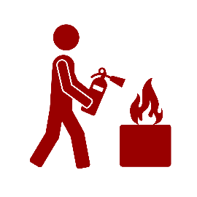
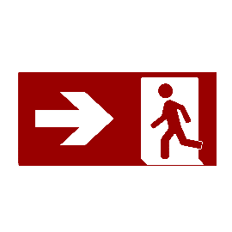


Gældende for DTU, May 2022
- Inform DTU’s Emergency Management – call (+45) 4525 3355

5
Notify
- Where possible, commence rescue and fire extinguishing actions
(do not expose yourself to danger)

4
Limit the fire
- Shut down elements that could pose a risk
- Take personal items with you – if possible
- Close doors to prevent fire and smoke spreading

3
Initiate DTU’s evacuation procedure
- Call 1 1 2
- Provide information – WHAT, WHERE, and WHO
2
Raise the alarm
- Immediately alert people in danger
(consider your own safety)

1
Alert
Fire and evacuation instruction

