


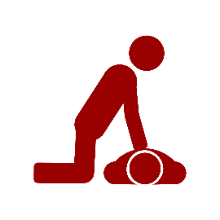
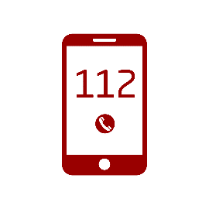


Gældende for DTU, November 2020
- Inform DTU’s Emergency Management – call (+45) 45 25 33 55
- Inform your own management
- Register the incident in DTU’s Injury app or via DTU Inside

7
Notify

- Be calm and provide assistance

6
Give psychiatric first aid

- If possible, send someone who can direct them

5
Receive the ambulance

- Give first aid
- Send someone to get an AED, if possible

4
Give first aid

- Call 1 1 2
- Provide information – WHAT, WHERE, and WHO

3
Raise the alarm

- Check for consciousness, breathing, and the person’s general condition

2
Assess the person

- Stop or limit the incident
(consider your own safety)

1
Establish safety

Severe injury

