




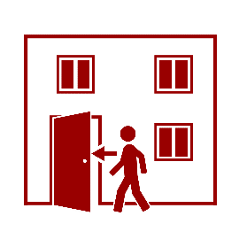

Gældende for DTU Risø Campus, November 2020
- Follow the instructions issued via the PA system
- Follow instructions received from DTUalarm (SMS alerts)
- Monitor Inside for updates
7
Follow the instructions given

- This is located near XXXX

6
Go to the building’s indoor assembly point

- Stop ventilation systems, where possible and sound
(consider your own safety)

5
Stop ventilation systems

- Inform others to do the same

4
Close all doors and windows

- Make your way immediately into the nearest safe building
- Inform others to do the same

3
Invacuation (go indoors)

- The siren warning is activated by the Gate. A 15-second constant tone will be played over the PA system

2
Siren warning

- Call 1 1 2 in case of acute danger
- Inform the Gate (portvagten) – call (+45) 46 77 44 44
- Inform DTU’s Emergency Management – call (+45) 45 25 33 55

1
Raise the alarm

Radioactive leak to outer environment

