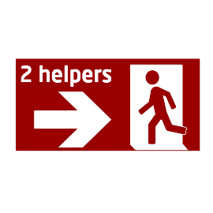


These instructions apply to DTU, sep. 2021

- The other helper seeks out the emergency services and the resource person (orange vest) and informs them of the location of the person and the other helper

3
Share information
- If obstacles arise, then one helper, if possible, remains with the person and provides care
2
Care
- The person must be assisted by two helpers, who together accompany the person to free terrain or other safe area
(Everyone can take on the role of helper)

1
Assistance
Evacuation - special needs
(Visible or invisible challenge)

