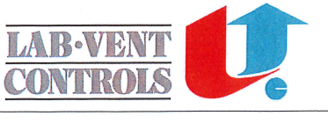

Instructions regarding use of Airflow-Control
Ventilated hood / point suction
General rules:
- Allways place test equipment within the workzone in the ventilated hood or as close to the point suction as possible.

- Avoid massive test equipment which will hinder the ventilation.

- Allways use suitable working clothes .

- Should errors involving health or safety risks occur, stop working at the ventilated hood or point suction immediately. Set up the “Out of order” sign and inform the responsible manager.

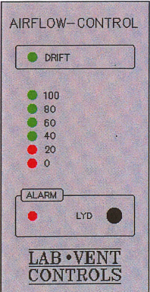
Drift: - Indicates the Airflow-Control has started and the air velocity is correct.
100: - Indicates that the airvelocity is on the selected level.
80-60-40: - Indicates that the airvelocity is below the selected level.
20-0: - Indicates to low velocity - alarm
Alarm: - Indicates low velocity by flashing a red light and activating
a sound.

Lyd: - The sound signal can be silenced by pressing the sound button.
Fejl på - Green light (DRIFT) is turned off and constant red light
230V (ALARM) is turned on. The sound from the alarm is constant
Forsyning: for 1 minute and after that the red light will be on constant.

