Research Evaluations DTU
Evaluation guidelines and templates



DTU Policy and Relations,

Policy Office

Contents

Main aspects of DTU’s research evaluation 4
Expert panel 5
The panel’s tasks 5
Nomination of panel members 5
Nomination of chair 6
Communication with panel 6
Self-evaluation report 7
Report structure 7
Report content 7
Profile of the department 7
PhD school (max 3 pages) 7
Conclusion 9
Annexes 9
Bibliometric analysis (Annexes D and E) 9
Site visit 10
Evaluation guidelines 12
Evaluating the sections/department 13
Evaluation of the PhD programme 14
Evaluating the research facilities 14
Marks 15
Presentation of findings 16
Verbal feedback 16
Evaluation report 16
Usage of the report 16
Practicalities – Panel members 18
Before site visit 18
Panel members’ travel to and from DTU 18
Hotel 18
During site visit 18
Transport from hotel to campus 18
After the site visit 19
Practicalities and division of labour - Department and central coordinator 19
State of affairs 19
Before site visit 19
Department 19
Central coordinator 19
During site visit 19
Department 19
Central coordinator 20
After site visit 20
Department 20
Central coordinator 20
Post-evaluation 20
Department 20
Central coordinator 20
Annex 1 – Nomination of panel members 22
Annex 2 – Annexes for the self-evaluation report 24
Annex A - Annual report indicators 25
Annex B – The department’s finances from the past 5 years 26
Annex C – Overview of sections 27
Annex D – Bibliometric Analysis: Department and Sections 28
Annex E – Bibliometric Analysis: Heads of Sections 29
Annex F - Statistics for the PhD school at DTU dept.name 31
PhD intake 31
Figure 1 31
PhD population 32
Figure 2 32
PhD graduates 32
Figure 3 32
PhD financing sources 33
Figure 5 33
PhD supervisor programme 34
Annex G – Organization of PhD studies at DTU 35
The Danish PhD programme 35
Objective and content of the Danish PhD programme 35
Tools for monitoring progress toward a PhD at DTU 35
The PhD programme in an international context 36
The structure of the PhD programme at DTU 36
PhD statistics at DTU 37
Annex H - A brief explanation of the terms Researchers and Members of Faculty 40
Annex I – Tenure Track at DTU 41
DTU tenure track 41
DTU tenure track career plan 41
Evaluation process 41
Job security 41
Annex J – DTU in Profile 42
Profile (dtu.dk) 42
Annex K – Optional annexes from the department 43
Annex L – CV Template 44
Annex M – Programme for the site visit 45
Annex N – Map of Campus 47
Annex 3 – Template for the evaluation report 48
1. Preface 50
2. Sections 50
Section a 50
Section b 50
Section c 50
Section nn… 50
3. PhD school 50
4. Research facilities 50
5. Executive summary: Department as such 50
Annexes 50
Annex 1: Panel members’ CV’s 50

Main aspects of DTU’s research evaluation

All departments at the Technical University of Denmark (DTU) are to be evaluated every sixth years. The evaluation of the individual department is carried out by an international expert panel and is based on a self-evaluation report by the department and a site visit to DTU by the panel.

The overall purpose of the evaluation exercise is three-fold:
- to have the quality, quantity and prospects of the research effort assessed by world leading experts,
- to enable a comparison with activities at similar institutions elsewhere in the world, and
- to ensure that the research strategy of the department is right.

The evaluation will include past performance and assess strengths, weaknesses, opportunities and threats (SWOT). It should, however, be clearly future-oriented and strive to contribute significantly to each department’s long-term development plans and research strategy.

The evaluation needs to be in-depth and thorough to ensure the commitment of the scientific personnel in the process. For the same reason, all research groups within each department must contribute actively to the evaluation process, including preparing the self-evaluation report, participating at expert visits and following up on the evaluation.

The quantitative information on research and research results will be based on known and well-defined parameters and will use data gathered in connection with DTU’s Annual Management Cycle i.e. the strategy paper called Development Goals and Measures.. In addition, publications and citation indicators will be drawn from DTU Research Analytics Platform (based on Web of Science/InCites).

As a general rule, the bulk of results of the evaluation presented in an evaluation report are internal to DTU and should be treated as confidential, however as DTU is a public institution, subject access can be requested.

Paragraphs on PhD education will be public documents and may be reviewed by the relevant ministries in connection with random checks. The executive summary can be used freely by the department and the Provost as they see fit.

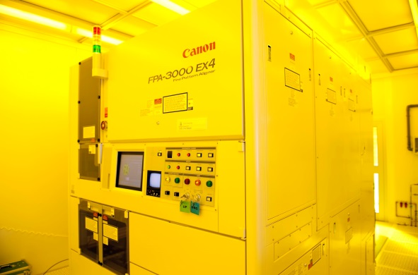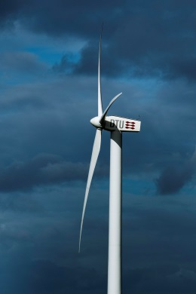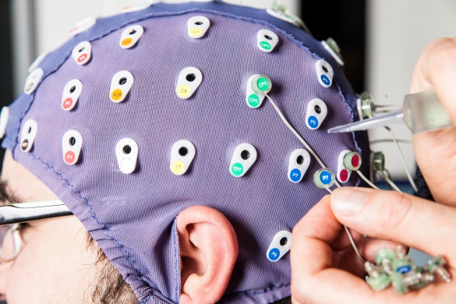

Expert panel
To ensure the objectivity and quality of the evaluation, DTU will invite a panel consisting of external experts to evaluate the research, researcher education and research infrastructure of each department.

The panel will consist of 4–6 internationally recognized and active researchers at professor level. Experts from non-academic organisations such as companies and research institutes may be included to the extent that it is scientifically relevant and they have the necessary research credentials. DTU will ask one of the experts to chair the panel.

The panel’s tasks
- Assess the current quality and prospects of the research, researcher education and research infrastructure of the department
- Recommend future actions

The panel will do so based on the self-evaluation report, the site visit and their knowledge of the field, trends and international institutions similar to DTU.

Nomination of panel members
The department nominates candidates for the expert panel.

The department can nominate 4-6 panel members based on the size of the department:
- 1-200 members of staff = 4 panel members
- 200-300 members of staff = 4-5 panel members
- 300+ members of staff = 4-6 panel members

The department should consider the following when nominating panel members:
- Must be recognized top researchers at least at professor level and can be research leaders or in university management positions.
- Should supplement each other in term of fields of study
- Should be diverse, i.e. numerous nationalities, men and women alike (nominate 50 % women)
- Should preferably be international researchers, i.e. work outside Denmark
- Should be able to act as independent objective agents i.e. should not have any active or planned collaboration with the department
- Can have been a part of a previous research evaluation at DTU

The department must describe any research collaboration and joint projects and publications for each nominated candidate. When nominating panel members, please use Annex 1.

Aside from the self-declaration of any past collaborations the suggested panel members will be subjected to a co-publication analysis which will uncover any overlooked collaborations. On the basis of this, the Provost of DTU may disqualify a candidate, if the relationship between the candidate and the department might create uncertainty about the independence of the evaluation.

Nomination of chair
Once the panel is set, the department nominates a first and second priority for chair of the panel. The chair should be nominated based on leadership skills rather than academic prominence.

Communication with panel
To ensure the objectivity of the evaluation, direct communication between panel members and department staff before or after the site visit is advised against.

Contact information

Central coordinator
research-evaluation@dtu.dk

All communication with the panel and its members, before and after the site visit, will be handled by the central coordinator appointed by the Provost.

Interaction between the department subject to evaluation and the panel is limited to the duration of the site visit. If either party wishes to communicate with the other, the contact must be facilitated by the central coordinator.

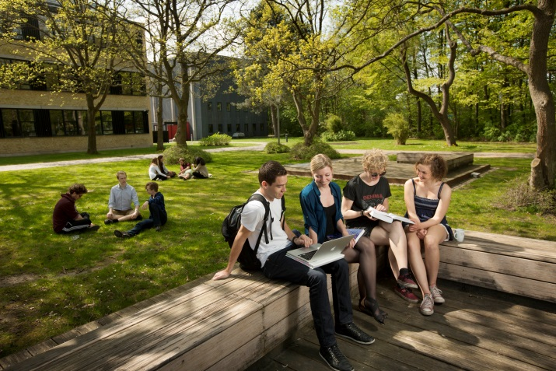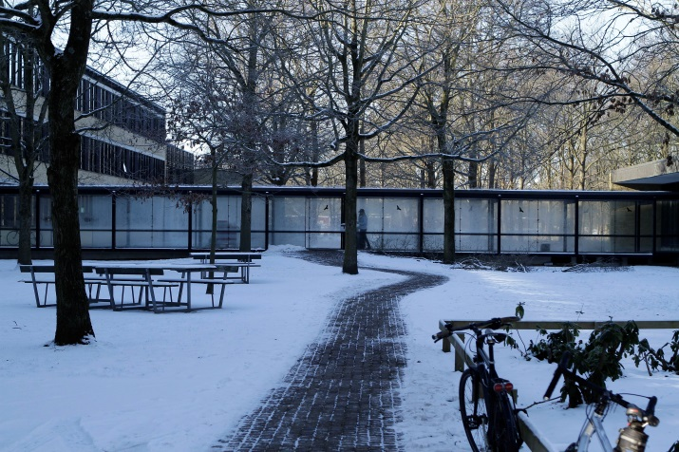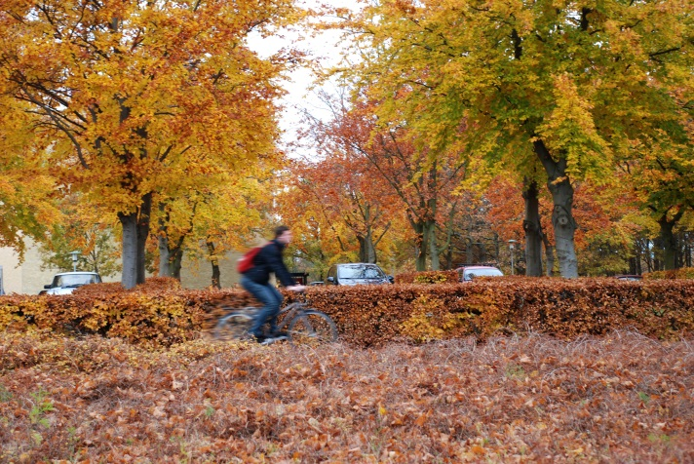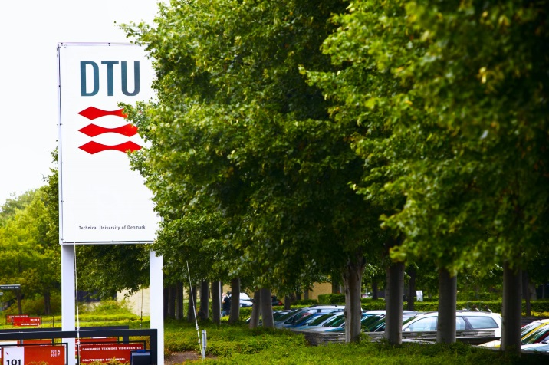

Self-evaluation report
The expert panel will receive a copy of the self-evaluation report approximately 1 month prior to the scheduled site visit.

A self-evaluation report consists of a descriptive part, a concurrent analysis of strengths, weaknesses, opportunities and threats (SWOT) and quantitative data on research production, citation impact and similar parameters (see annexes).

Report structure
- Max 30 pages
- In English
- Should be understandable without referring to annexes

Report content

Profile of the department
The profile should include descriptions of the department’s:
- Introduction
  - recent history and organizational development (approx. five years)
  - assignment portfolio, including a description of the assignments of Faculty and research staff
  - follow-up on the last research evaluation
- overall research profile
- groups, sections and centres, which should include:
- the scientific field
- an assessment of strengths
- an assessment of areas of potential future development
- key challenges and opportunities for development in the scientific field in the next decade
- research plan (in brief)
- special factors that should be noted, if relevant

PhD school (max 3 pages)
According to the Danish University Act, all Danish universities are required to evaluate their PhD schools. Because of this legal requirement, the department’s self-evaluation report and the final evaluation results concerning the PhD school are public and not confidential (see Annex G for further explanation of the Danish PhD education in a DTU context).

Please include the following sentences in the self-evaluation report: “According to the Danish PhD Order, the PhD education in Denmark is rated at 180 ECTS points equivalent to 3 years of full-time study. A majority of the PhD students are employed by the university, and as part of their employment contract they may be assigned to work for the department for up to 420 hours during the 3 years.“

Evaluation criteria
The self-evaluation of the department’s PhD school should consist of
- The PhD school’s comments on data provided (annex A and annex F)
- PhD research output and employment of PhD graduates

    - Please describe the PhD research output including article publications by the PhD students
    - Please describe where the PhD graduates are employed after graduation from DTU

- Description of the PhD school organization
    - Please provide a brief description of the organization, staff, and administrative/decision procedures including the involvement of the PhD committee

- Description on how the PhD school works with:
  - PhD intake, diversity and well-being
    - Please describe how the PhD school works with onboarding new PhD students and integrating them in relevant research groups/networks at the department and outside DTU
    - Please describe how the PhD school handles dropout rates, which initiatives have been taken to identify causes of drop out of PhD students and which actions the PhD school has taken to reduce dropout rates
    - Please describe how the PhD school follows up on first year interviews with PhD students
    - Please describe how the PhD school supports a positive working environment for PhD students
  - PhD supervision and the development of the PhD school
    - Please describe the strategic goals of the PhD school, and provide details on plans for implementation (e.g., 2-4 year time span)
    - Please describe any synergies obtained from collaboration with other DTU departments
    - Please describe how the PhD school works with developing and supporting the quality of the PhD training and supervision quality, including how match of expectations is ensured between PhD students and their supervisors
    - Please describe how the PhD school works with the composition of the PhD course catalogue and how a high quality of courses is ensured.

Conclusion
- A coherent conclusion, including the department’s summary of its development plan and research strategy (UMV)
- A brief analysis of strengths, weaknesses, opportunities and threats (SWOT) at department level

Annexes
Annexes with more detailed information on the department are to include:
- Annual report indicators
- The department’s finances from the past 5 years*
- Overview of sections
- Bibliometric analysis of Department and Sections*
- Bibliometric analysis of Heads of Sections*
- Statistics for the PhD school of DTU dept.name*
- Organisation of PhD studies at DTU**
- A brief explanation of the terms researchers and members of faculty**
- DTU Tenure Track**
- DTU in profile**
- Optional appendixes from the department (– in moderation)
- CV Template
- Programme for the site visit
- Map of campus sites

* annexes provided by DTU administration
** generic annexes, find in appendix to this manual

Bibliometric analysis (Annexes D and E)
The library prepares a bibliometric analysis of the overall department as well as of each section and of each Head of Section.

All researchers to be included in the analyses must have an ORCID (Open Researcher and Contributor ID) and add publications to their ORCID profile.

The source of the analysis is DTU RAP, DTU Research Analytics Platform, which is based on:
- Publications retrieved from Web of Science using the researchers’ ORCIDs (and Web of Science ResearcherIDs if available)
- Publications authored by current scientific staff

The analysis of the department/sections is based on the past full five years and includes the following data:
- Number of scientific staff above Postdoc level
- Number of Web of Science publications in the five-year period
- Citations: Number of times the publication set has been cited up until the date of analysis.
- Citation Impact: Average number of citations per publication.
- Category Normalised Citation Impact: Citation impact (citations per publication) normalised for subject (Web of Science journal category), year, and publication type. A value of one represents performance at par with world average, values above one are considered above average, and values below one are considered below average.
- Share of Publications in Top 10%: Share of publications in the top 10% most cited, based on citations by subject (Web of Science journal category), year, and publication type.
- Share of Publications in Top 1%: Share of publications in the top 1% most cited, based on citations by subject (Web of Science journal category), year, and publication type.

The analysis of the Head of Section is based on his/her full publication career and includes:
- Year of first publication in Web of Science
- Total number of Web of Science publications
- Citations: Number of times the publication set has been cited up until the date of analysis.
- Citation Impact: Average number of citations per publication
- h-index: Number of publications in the collection (h) that has received at least (h) citations. For example, Researcher A has an h-index=13 if he/she has published at least 13 documents for which he/she has received at least 13 citations.

Site visit
The expert panel will visit DTU for 3 days, and is expected to use the last half day to formulate the first draft of the report. In planning the site visit, the department must set aside amble time for the panel to discuss and process their findings amongst themselves.

Before the visit, DTU will give the experts the opportunity to identify specific people, categories of staff etc. that they would like to meet during their visit. The panel may also decide to contact the department’s staff during the visit.

The Head of Department will telephone/online meet the panel chair approximately one week before the site visit to discuss the programme for the site visit.

The Head of Department or the local coordinator should follow the panel around during the entire site visit to ensure that no questions go unanswered and that all practical needs are met. However, during the internal panel discussions, the panel should be left to themselves.

During the visit, the Head of Department and the heads of the research groups will have the opportunity to make short oral presentations of max. 5-10 minutes to elaborate on the self-evaluation report. The department should strive to keep the presentations concise and to the point and not repeat the self-evaluation report.

The chair of the panel will have a short phone/online meeting with the provost on the second day of the site visit. The department should coordinate meeting this with the provost’s PA.

Suggested framework for expert panel visits (see Annex K):

Day 0
- General presentation of DTU and evaluation format by the Provost
- Dinner – panel, Provost, Head of Department

Day 1
- Discussion of task division (panel only)
- Visits to research groups: During the three day visit all research groups should be visited
- The Head of Department and the heads of the research groups, sections and centres give oral presentations of the department (attending: panel, heads of department and of research groups)
- Tour of facilities and presentations of the research facilities (may be divided so that each research group makes a presentation in connection with its meeting with the panel)

Day 2
- Continuation of visits to the department’s research groups
- Meetings with individual staff or categories of staff that the expert panel has asked to meet
- Telephone conversation between panel chair and Provost

Day 3
- Continuation of visits to the department’s research groups
- Meetings with individual staff or categories of staff that the expert panel has asked to meet
- The expert panel prepares the first draft of the evaluation report
- The expert panel concludes its visit with an oral briefing to the department and a debriefing with the Provost, Head of Department and Deputy Director if relevant

Evaluation guidelines
The panel should assess the department based on
- the self-evaluation report
- the site visit
- and their knowledge of the field, trends and international institutions similar to DTU

The panel is asked to read the self-evaluation in preparation of the site visit and consider the programme for the site visit. The panel chair is welcome to suggest changes to the programme. The Head of Department will telephone/online meet the chair approximately a week before the site visit to discuss the programme.

The panel should strive to evaluate the department in the spirit of a critical friend when:

- assessing the current quality of the research conducted at the department (mark and comment)
- recommending future actions

The panel is asked to evaluate(see template in Annex 3):
- the department as a whole (mark and comment)
- the individual sections (mark and comment)
- the PhD school (mark and comment)
- the research facilities (comment)

The panel should base their evaluation on the following criteria and subcriteria:

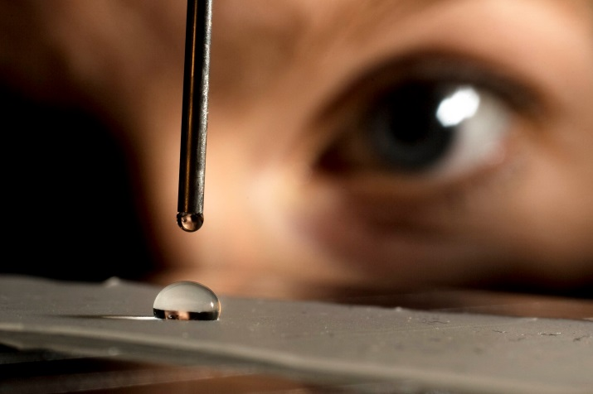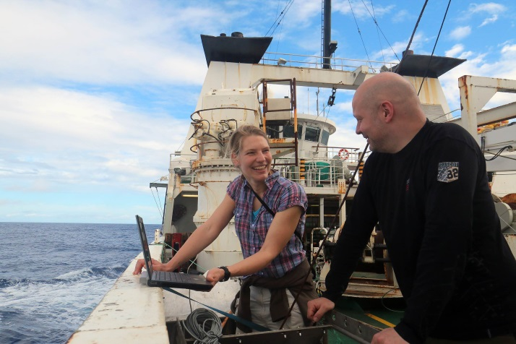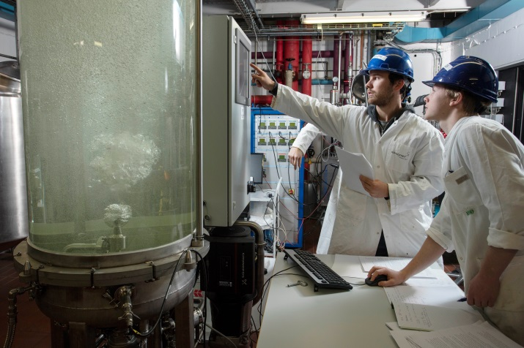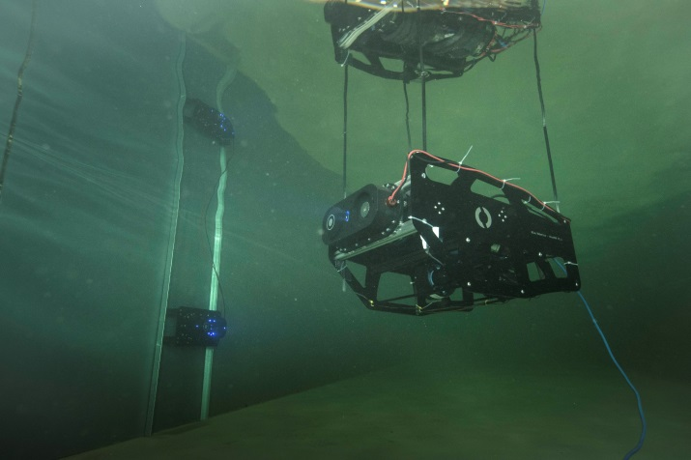

Evaluating the sections/department
The research sections should each be given a mark (see below), a status remark and recommendations based on the following parametres:

Criteria | Subcriteria
Research programme | - Leadership  - Mission and objectives  - Strategy and policy  - Adequacy of resources  - Funding strategy  - Facilities  - Academic reputation  - Relevance to society  - Balance of strengths and weaknesses
Quality | - Originality of the approach and ideas  - Significance of the contribution to the field  - Coherence of the programme  - Publication strategy  - Prominence of the programme director  - Quality of scientific publications (scientific impact)  - Quality of other results  - Quality of research facilities at the department
Productivity | - Number of PhD dissertations  - Number of scientific publications  - Distribution of published output within the group, section or center
Relevance | - The advancement of knowledge  - The dissemination of knowledge  - The implementation of knowledge
Prospects (vitality and feasibility) | - The past and current scientific performance  - The plans and ideas for the future  - The age distribution and genereral diversity of the staff

Evaluation of the PhD programme
The Danish PhD programme is a 3-year graduate programme. The programme is regulated by the Danish PhD Order, which leaves the Danish universities with limited possibilities to maneuver in terms of individual rules and guidelines. Annex G introduces the panel to the legal framework and organization of the PhD programme in Denmark, and at DTU.

The main part of the results of the research evaluation is for internal use only. However due to legal requirements, the results of the PhD evaluation are public documents and are thus not confidential.

Please consider the following areas related to the PhD programme at the relevant PhD school:
- PhD research output and employment of PhD graduates
  - PhD research output including article publications by PhD students
  - Where are PhD graduates employed after graduation from DTU
- PhD intake, diversity and well being
  - Statistics on recruitment (number of intake, graduates, diversity, etc.)
  - Participation in research environments (integration in relevant research groups within the department and outside DTU)
  - Initiatives to support positive well being for PhD students

- PhD supervision and the development of the PhD school
  - PhD supervision (supervisor’s competence development, initiatives to improve quality of the supervision)
  - The composition of the course catalogue and how the PhD school works with courses offered by the PhD school
Please include the attached statistics in your evaluation of the PhD programme at the relevant PhD school.

Evaluating the research facilities
Assess the research facilities the department has presented in the self-evaluation report and during the site visit. Facilities can be research instruments, laboratories, HPC etc.

Assess the facilities based on:
- Quality of research facilities in terms of state of art and wear and tear
- Quality/quantity of user support especially focussing on expert user support for e.g. analysis of results
- Accessibility of the research facilities for the researchers
- Use of facilities today and the near future
- Future possibilities in existing facilities
- Planned research infrastructure of the department in connection to the strategy of the department and the panel’s own recommendations.

Marks
The panel is asked to mark the research activities of the department. Each section, the PhD school and the department as a unit should receive a mark from 1.0-4.0. 4.0 is the best possible mark.

- 4.0: Work that is at the cutting edge internationally, and which most likely will have an important and substantial impact in the field. The research unit is considered amongst the international leaders.

- 3.5

- 3.0: Work that is internationally competitive and is expected to make a significant contribution; nationally speaking at the forefront in the field. The research unit is considered an international player and a national leader.

- 2.5

- 2.0: Work that is competitive at the national level and will probably make a valuable contribution in the international field. The research unit is considered internationally visible and a national player.

- 1.5

- 1.0: Work that is solid but not exciting, will add to our understanding and is in principle worthy of support. It is considered of less priority than work in the above categories. The research unit is nationally visible.

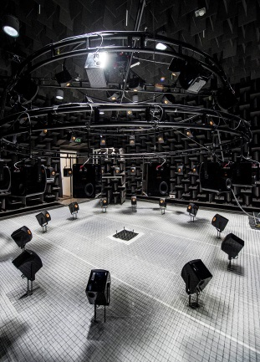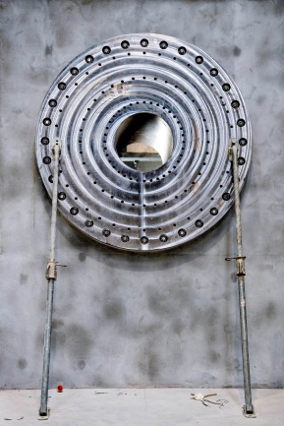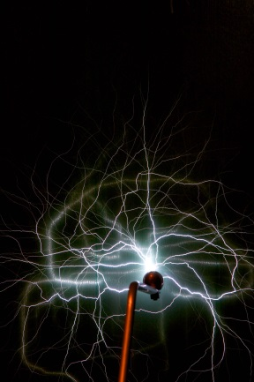

Presentation of findings
The panel presents its findings to the Provost and the department through a verbal presentation at the end of the site visit and in a written report to the Provost and Head of Department.

Verbal feedback
The end of the site visit is set aside for the panel to make a brief presentation of their preliminary findings.

The presentation consists of an approximately 30 minutes presentation to the staff of the department possibly followed by a Q&A session for 10-15 minutes. The panel can use powerpoints etc. or not.

Following this is a de-briefing session of about 45 minutes between the panel, the Provost, and the Head of Department.

Evaluation report
The expert panel presents its overall evaluation in a written report.

The report should contain an evaluation of :
- The department as a whole (internal use)
- Research activities of each section/centre (internal use)
- The PhD programme (public document)
- The research infrastructure (internal use)
- An executive summary of the evaluation findings (to be freely used by the department and Provost)

Each section, the PhD programme and the department as such should receive a mark from 1.0. - 4.0.

The expert panel will send a draft report to the central coordinator within 1 month of the site visit. The management of the evaluated department will have 1 week to submit comments and corrections of factual errors to the panel via the central coordinator. The panel will send the final report to the central coordinator within 2 weeks of receiving the comments and corrections of factual errors.
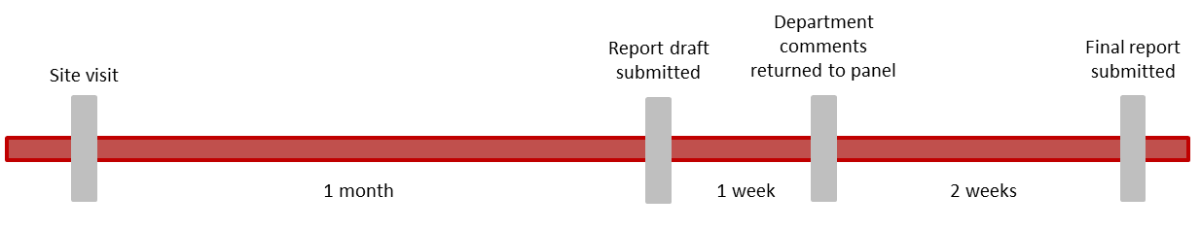
Figure 1: timeline for submission of evaluation report

Usage of the report
The bulk of the evaluation report is considered confidential and internal to DTU, and is addressed only to the Head of Department and Executive Board of DTU/Provost.

However, the paragraphs on the PhD programme are considered public documents and can be handed over the relevant ministry upon request. The executive summary of the evaluation findings, can be used freely by the department and the Provost and shared with both internally and externally.

According to Danish law, subject access can be requested and DTU can be forced to hand over parts or all of the report.

Practicalities – Panel members
The following chapter provides guidelines and describes some of the practical issues that surround the evaluation such as travel arrangements.

Before site visit

Panel members’ travel to and from DTU
The panel members make their own travel arrangements to and from DTU. It is the easiest and most flexible for all involved parties.

When planning the trip, the panel members should follow these guidelines:
- Panel members living in Europe
  - Max. amount for return flight/train 1000 euro
  - Travel commercial
- Panel members living outside Europe
  - Max. amount for return flight/train 3000 euro
  - Can travel business class
- DTU cannot reimburse the following:
  - minibar expenses
  - hard liqueur expenses

DTU reimburses all travel expenses shortly after the site visit. If the panel member has disbursed the travel fees personally, the reimbursement is done through an electronic reimbursement system (e-form). If the panel member’s place of employment disburses the travel fees, the place of employment must invoice DTU to receive reimbursement. Information about the different reimbursement methods will be detailed in an email shortly after the end of the site visit.

Hotel
The panel members must inform the central evaluation coordinator if they will need an extra night before or after the site visit to allow for flight schedules etc. The central coordinator will email the panel to ask for this information well in advance of the site visit.

DTU will pay for maximum 1 night before the site visit and 1 night after the site visit.

If a panel member wishes to bring a partner along for the visit, the panel member holds any additional costs himself or herself. The partner is not invited for the start-up dinner as work and private life are usually kept separate in Denmark.

During site visit

Transport from hotel to campus
The panel will commute in taxis between campus and hotel. The panel share a large taxi or two regular taxis to get to and from the campus. Taxi fees will be reimbursed along with other travel expenses

Transport time varies depending on traffic, but is usually between 10-30 minutes.

The central coordinator will book taxis for the first morning and local coordinator will book taxis for the remainder of the visit.

After the site visit
Right after the site visit, the panel will be emailed information about honorarium and travel reimbursement, as well as timeline for submission of first draft and final report.

Practicalities and division of labour - Department and central coordinator

State of affairs
- DTU’s Provostis responsible for DTU’s research evaluations
- The Policy Office (APR) will coordinate the process on behalf of the Provost
- There should be no direct contact between the panel and the department from the first nomination of panel members until the department has received the final evaluation report
- The central coordinator from the Policy office can always be reached at research-evaluation@dtu.dk
- All communication between panel and department should go through the central coordinator until the panel has submitted the final report
- The department must appoint a local coordinator of the process. The local coordinator should be an administrative officer
- To avoid confusion, the local coordinator will act as the department’s single-point-of-contact. This means that all communication from the department to the panel or the Provost should go through the local coordinator to the central coordinator

Before site visit

Department
- Arrange (and pay) lunch etc. for the panel during the site visit
- Arrange (and pay) transportation between different campuses if relevant
- Arrange telephone call between Provost and panel during the site visit
- Arrange for guest-wifi access

Central coordinator
- Arrange hotel for the panel
- Arrange dinners for the panel
- Arrange telephone call between Head of Department and panel chair
- Book taxi for the first morning of the site visit

During site visit

Department
- Book taxis to and from the hotel/airport during the site visit (excl. first morning)
- Walk the panel from location to location (typically this is done by Head of Department or local coordinator)
- Assist the panel with practical issues of all sorts
- Provide the panel with extra material when requested. If the requests seem out of the ordinary, contact the central coordinator for advise (research-evaluation@dtu.dk)

Central coordinator
- Be available for questions from department or panel

After site visit

Department
- Comment on first draft of the panel’s evaluation report. Comments should be limited to factual errors and misunderstandings as well as sensitive information.

Central coordinator
- Send practical information to the panel regarding honorarium, travel reimbursement and timeline
- Pay honorarium and travel reimbursement
- Receive draft reports and pass them on to department
- Receive comments from the department and pass them on to panel
- Receive final report and pass it on to department and Provost

Post-evaluation

Department
- Use findings and recommendations from the report in day-to-day management and long term planning
- Head of Department and Provost will discuss the report at a one-to-one meeting
- Present findings and recommendations from the report and how the department will utilise these in the department’s Development Goals and Measures (UMV)

Central coordinator
- Book follow-up meeting between the Provost and Head of Department
- Summarise the findings and recommendations of the panel report for the executive board
- Submit the PhD evaluations and self-evaluations to DTU’s central PhD Office and attend PhD programme meetings regarding of the results of the evaluation as an observer representing the Provost. The PhD Office report to the Ministry

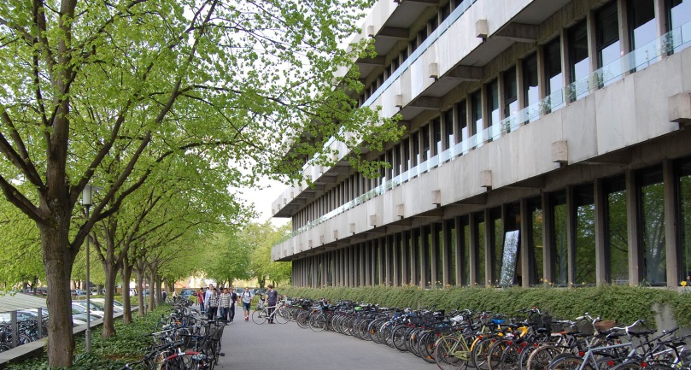

Annex 1 – Nomination of panel members
Department: DTU [short name]
Priority | Research Area(s)* | Name | Email address | Title | Institution | ORCID or Personal website | Nationality | Gender | Collaborations (5 years back - 1 year in the future)** | Nature of collaborations
1
1
1
1
1
1
2
2
2
2
2
2
3
3
3
3
3
3
4
4
4
4
4
*The research area(s) of the DTU department which you expect the panel member to be the primary expert. If your first priority declines the invitation, the Policy office will invite the next person within the same research area.

** Objectivity is important in research evaluations, and therefore we recommend that you do not nominate anyone with whom you have collaborated within the last 5 years or with whom you plan to collaborate within the next 12 months. If you choose to do so anyhow, please elaborate the nature of your collaboration and the Provost will decide if the nominated can be invited or not.

Example - purely fictional
Priority | Research Area(s)* | Name | Email address | Title | Institution | ORCID or Personal website | Nationality | Gender | Collaborations (5 years back - 1 year in the future)** | Nature of collaborations
1 | water | Jörg Pietersen | JP@edu.ca.us | professor | University of California | XXXXX | US | M | none
1 | Air | Qi Zhingh | QuZhngh@baka.ch | professor | Baka University | www.blabla.com | CN | F | Research project: Air Polution | 2009-2014 - DTU coordinater Lars Sørensen (ORCID XXXX) the project was a large project with 20+ partners and there was little to no direct contact between Qi Zhingh and Lars

Annex 2 – Annexes for the self-evaluation report

Annex A - Annual report indicators
The department should insert the indicators from the latest Development Goals and Measures (UMV) report of the department.

UMV indicators can be downloaded at amc.dtu.dk.

(Instituttet skal indsætte måltal fra instituttets seneste UMV. Måltal kan downloades på amc.dtu.dk)

Annex B – The department’s finances from the past 5 years

Total funding
(To be filled-in by the business controller of the department – should be submitted to Team Analyse og Fortolkning for exchange rate approvel etc.)

Financing and research funding | Year X | Year X | Year X | Year X | Year of evaluation
All figures in millions DDK (Euro)
Core funding (from DTU)
External research grants, spending
Commercial activities
Total

External funding granted, mEUR
past three + Current year
  - (To be filled-in by the finance department – Team Analyse og Fortolkning.)

 | 20XX | 20XX | 20XX | [date]20XX | Total
Section X
Section X
Section X
Section X
Section X
Total

External funding spent, mEUR
past three + Current year
  - (To be filled-in by the business controller of the department – should be submitted to Team Analyse og Fortolkning for exchange rate approvel etc.)

 | 20XX | 20XX | 20XX | [date]20XX | Total
Section X
Section X
Section X
Section X
Section X
Total

The department’s financial circumstances can be seen in perspective to DTU’s annual Financial statement

Annex C – Overview of sections

Number of faculty members, other scientific staff, PhD students and courses
  - Current year + past two
  - (To be filled-in by the department)

 | [date] Year X (Current year) |  |  |  |  | Year X | Year X
Section | Faculty (persons) | Faculty (FTE) | Other scientific staff (persons) | Other scientific staff (FTE) | Courses (5 ECTS) | PhD graduates | PhD graduates
Section X
Section X
Section X
Section X
Section X
Section X
Total

Annex D – Bibliometric Analysis: Department and Sections
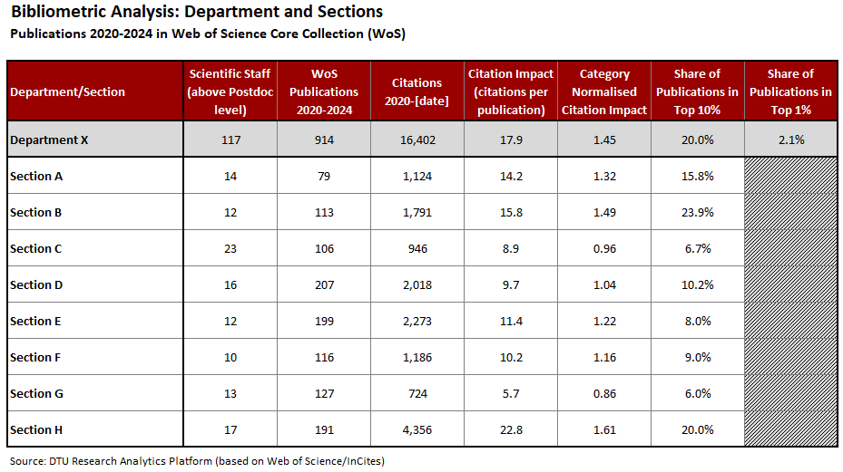

Annex E – Bibliometric Analysis: Heads of Sections
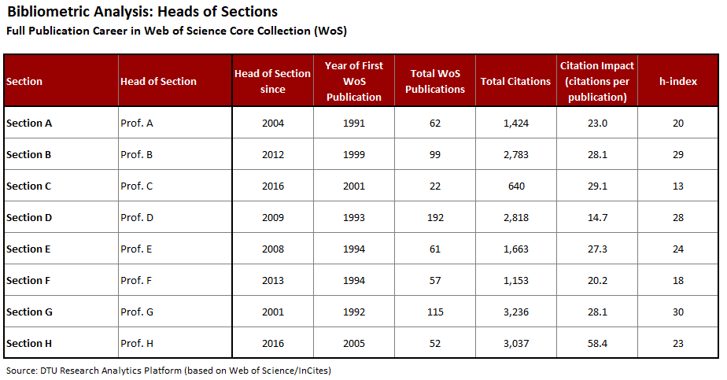

Annex F - Statistics for the PhD school at DTU dept.name
  - To be filled in by the PhD officers.

This appendix includes statistical data for the PhD school at DTU dept.name. The following data is presented:
- PhD intake during a 5 year period
- PhD population (as per 31.12.2024)
- PhD graduates during the 5 year period
- PhD financing
- Number of supervisors that completed DTU’s PhD supervisor development courses

PhD intake
Figure 1 below shows the PhD intake and the gender balance over a period of 5 years

Figure 1

PhD population
Figure 2 below shows the PhD population (data extracted 31.12.2024) at DTU dept.name during the period 5 year period

Figure 2

PhD graduates
Figure 3 below shows how many PhD students graduated from DTU dept.name per year over a period of 5 years:

Figure 3

PhD financing sources
Figure 5 below shows the financing sources for PhD projects at DTU dept.name during the period 5 year period (date –date).

Figure 5

The financing sources that are not self-explanatory are explained below:

- Co-funded, other
The project is partially funded by DTU and partially from a grant, which does not originate from a private company.
- ErhvervsPhD (Innovation Fond Denmark)
The project is funded by the Industrial PhD programme under Innovation Fund Denmark.
- Research Council
The project is fully funded by one of the Danish national research funds (excl. ‘ErhvervsPhD’ and the Danish National Research Foundation)
- Public funding
The project is funded by other public funds than research councils or the Danish National Research Foundation.
- Co-funded, company
The project is partially funded by DTU and partially from a grant from a private company.
- Foundations
All foundations other than the Danish National Research Foundation.
- Private funding
The PhD student pays his/her own salary plus a tuition fee to DTU.

PhD supervisor programme
DTU offers a four-module programme for PhD supervisors. The first module is mandatory for all new supervisors.

Annex G – Organization of PhD studies at DTU

The Danish PhD programme
The PhD programme is the highest level of education in the Danish education system. This paper serves to briefly introduce the Danish PhD programme and the PhD programme at DTU. The following are described in this paper:
- the objective and content of the Danish PhD programme
- tools for monitoring progress toward a PhD at DTU
- the Danish PhD programme in an international context
- the structure of the PhD programme at DTU
- PhD statistics at DTU

Objective and content of the Danish PhD programme
The PhD programme is a 3-year post-graduate programme educating PhD students at an international level to fill research, development and educational positions in the private and public sectors. The PhD programme is regulated by the provisions of the Danish PhD order.

The formal elements of the PhD programme for PhD students at Danish universities are outlined below:

- Independent research work under supervision (PhD project)
- Participation in active research environments including placement at external research institutions, typically 3-6 months
- Teaching and other forms of knowledge dissemination
DTU requires that all employed PhD students teach as part of their work obligation. PhD students externally employed are also, to some extent, required to teach at DTU as part of their knowledge dissemination
- PhD courses or other similar educational elements (approx. 30 ECTS, or 6 months full time study)
- PhD thesis
PhD students are enrolled at PhD schools at universities or higher degree artistic institutions. Most PhD programmes are commenced after completion of a Master’s degree under the EU Bologna BSc/MSc/PhD educational model (3+2+3 years respectively).

Several models for financing a PhD programme exist, yet it is required that the PhD schools ensure funding for the entire enrolment period. The programme may be financed fully via the university’s basic grant, fully via an external grant from e.g. Danish national research funds or private foundations or a combination of these. The programme may also be financed through collaboration between various institutional bodies, foreign scholarship programmes, the private sector or via the Industrial PhD Scheme. The majority of the PhD students at DTU collaborate with private industry.
Tools for monitoring progress toward a PhD at DTU
As part of the PhD programme, the students must prepare a PhD plan.
The PhD plan has several purposes, including:
- Ensuring that the principal supervisor and the PhD student carefully consider and formulate the purpose of the PhD’s study programme, methodology and study progress.
- To inform the PhD school of whether the planned study programme is of sufficiently high quality.
- Provide biannual assessments to enable the assessment of study progress.
DTU regularly monitors the progression of the PhD students’ studies through half-yearly reports. The reports are an important tool for the PhD students and the supervisors to keep the PhD programme on track. The half-yearly reports assess recent work and plans for upcoming months and enable actions to be taken if lack of progress is observed or if any other adjustments are needed.

A submitted PhD thesis is assessed by an expert committee composed of three members of which one member must be from the university awarding the degree, and two must be from outside DTU with at least one member being from an institution outside of Denmark. The supervisors are not allowed as members of the assessment committee. The thesis must be available to the public and be defended publicly.

The PhD programme in an international context
The structure and framework for the Danish PhD programme largely comply with the recommendations of the 10 Salzburg principles and the further development of these principles.

There are some variations as to how the PhD programme is structured in other countries, for example in terms of length of programme, standard workload (number of ECTS credits) and the status of the PhD students as either employees or students. Looking at a number of other European countries with comparable educational systems, the length of the PhD programme varies between 3 years (180 ECTS credits) and 5 years (300 ECTS credits).

The majority of PhD students at DTU are employed as PhD fellows and because of their status as employees are entitled to holiday, illness, maternity leave, etc. PhD students employed at a Danish university may be assigned to work for the institution, which at DTU corresponds to 420 hours over 3 years of employment. At DTU the employed PhD students are required to teach as part of this work obligation.

The Danish PhD students are expected to finish their PhD studies within the 3 years of enrollment and employment.

The structure of the PhD programme at DTU
DTU has 17 PhD schools; Each DTU department has an established PhD school and two of DTU’s centres has established a PhD school.

Each of DTU’s PhD schools has a PhD committee to obtain a close collaboration between the PhD committee and the PhD school. This organization also helps ensure that academic decisions are made close to the academic environment. Each PhD committee consists of an equal number of scientific staff and PhD students’.

The Provost has the overall responsibility for the PhD programme and each PhD School has an appointed Head of PhD School. DTU has a Forum for Heads of the PhD Schools that coordinates issues related to the PhD programme and enables strategic development. The Forum is led by the Provost.
External research evaluations continuously raise concerns regarding the length of the Danish PhD programme and non-research activities (420 hours). Although, DTU is unable to change the length and the requirements of the additional educational elements, the Danish PhD Order allows for a flexible interpretation of the educational elements (ECTS activities).

DTU aims to create more time for research for the individual PhD student by making ECTS activities more flexible and moving academic decisions closer to the academic environment.

PhD statistics at DTU
The number of PhDs enrolled at DTU is shown in the figure below.

The PhD intake at DTU in 2023 was 399 students of which 137 were women and 294 were international students.
The total number of DTU’s PhD population is shown in the figure below:

The number of PhD students enrolled at DTU is 1760 students (as per 31.12.2022).

Annex H - A brief explanation of the terms Researchers and Members of Faculty

Most researchers and members of faculty at DTU are full time employees. A Danish Full Time Equivalent position is 1924 hours/year or 37 hours/week.

DTU defines members of faculty as someone who is employed to do research and education. A member of faculty will spend 20-50 % of his/her time on education activities (preparation, lecturing, supervising and development).

DTU also employs researchers who are not responsible for education; however researchers can still spend up to 20 % of their time on education activities.

Researchers and members of faculty are in all other aspects equal. The position categories are not static; a researcher can become a member of faculty and a member of faculty can become a researcher.

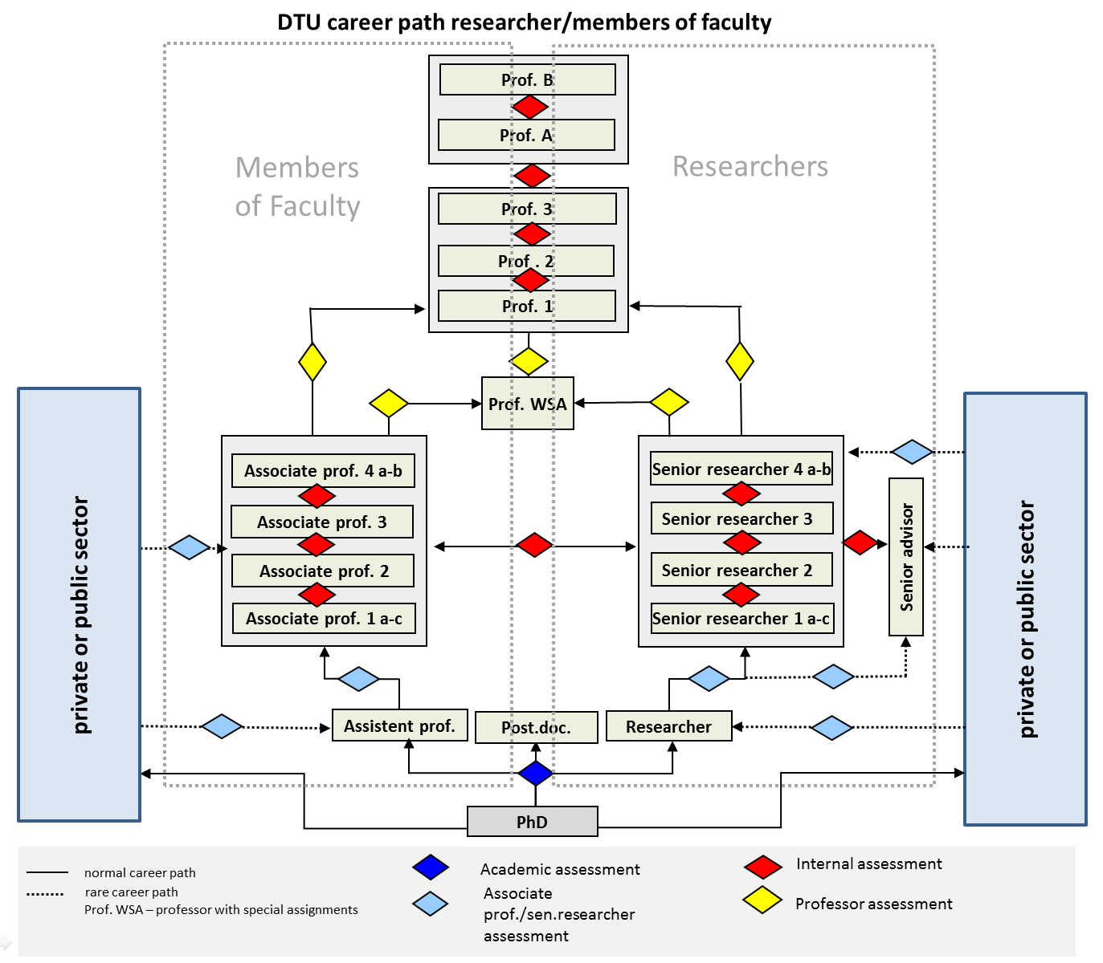

Annex I – Tenure Track at DTU

DTU tenure track
In 2020, the DTU tenure track programme was implemented at DTU and since March 1, 2020 all newly employed researchers and assistant professors have been employed in DTU tenure track. The DTU tenure track programme comprises the two career paths
- assistant professor -> associate professor -> professor
- researcher -> senior researcher -> professor

In DTU tenure track, highly qualified candidates are employed in an assistant professor or researcher position. After a maximum period of six years they are transferred to a permanent position as associate professor or senior researcher, respectively, if given a positive academic assessment at the end of the tenure track process.

DTU tenure track career plan
On commencement of the employment, the head of department/head of section will take the initiative for a meeting with the new employee to ensure that the employee is familiar with the requirements, guidelines, and expectations associated with the tenure track employment. At this meeting, the DTU tenure track career plan is filled in, setting the framework for the objectives for the employee’s development process.

Evaluation process
A number of annual evaluations have been included in the tenure track employment, as well as a midterm evaluation focusing on the individual employee’s development and documenting the employee’s performance.
Tenure track employees receive a midterm evaluation two years into their employment involving an external assessment. The evaluation aims at providing the employees with an indication of their eligibility for an associate professor/senior researcher assessment.
Employees in DTU tenure track will also be offered a mentor as a supplement to a manager’s supervision and guidance.

Job security
If you are employed as researcher or assistant professor in DTU tenure track, you are guaranteed a senior researcher/associate professor assessment without a job advertisement, and you are transferred to a permanent position as senior researcher/associate professor if you are found to be qualified in this assessment. You will receive full support from the department throughout your DTU tenure track employment in the form of mentor support and annual evaluations with your head of department/head of section.
No DTU employees are guaranteed lifetime employment. If your job performance is not satisfactory or if the department is forced to make reorganizations, you may—like everyone else—be given notice of dismissal under the existing rules and regulations.

Annex J – DTU in Profile
For a quick overview of DTU, please find the newest version of DTU in Profile at our website

Profile (dtu.dk)

Annex K – Optional annexes from the department
The department can insert relevant optional annexes (in moderation)

Annex L – CV Template
To be filled-in by the department (*mandatory)
*ORCID

*Name (year of birth)

*Degrees:
List year and degrees

*Positions:
List main periods and positions

*Research Area:
Short description 3-5 lines

Distinctions and awards:
List name of award and year

Memberships of scientific committees, review
List

*Web of Science publications: no.; Citations: no.; h-index: no.;

Scopus publications: no.; Citations: no.; h-index: no.;
Patents: no.

Books:
List main

Other innovation activities:
List main

*Supervision of PhDs, last 5 years – present (ongoing og finished in the last 5 years):
Title and year

*Grants, last 5 years (ongoing or finished within the last 5 years):
List grants

Research collaboration with other sectors, within the last five years:
List

*Selected publications
Include the titles of 5 selected publications

Annex M – Programme for the site visit
The template can be adjusted to meet the need of the individual department.

Please submit the Programme as a separate file as well.
Day 0
18.00-19.00 | General presentation of DTU and evaluation format by the Provost | Panel, Provost, Head of Department | Hotel, meeting room X
19.00-21.30 | Dinner | Panel, Provost, Head of Department | Hotel, Restaurant X
Day 1
09.00-10.15 | Presentation of Department: introduction, research self-evaluation, strategy | Head of Department | Building X, room Y
10.15-10.30 | Coffee break
10.30-11.00 | Internal panel discussion | Panel | Building X, room Y
11.00-12.30 | Research section 1 | Staff from section + panel | Building X, room Y
12.30-13.30 | Lunch |  | Room/canteen X
13.30-15.00 | Laboratory visit | Staff from section + panel | Building X, room Y
15.00-15.30 | Coffee break
15.30-17.00 | Research section2 | Staff from section + panel | Building X, room Y
17.00-17.30 | Internal panel discussion and 1. day round up | Panel | Building X, room Y
18:30 | Dinner at hotel for panel experts |  | Hotel
Day 2
09.00-10.30 | Research section 3 | Staff from section + panel | Building X, room Y
10.30-11.00 | Coffee
11.00-12.30 | Research section 4 | Staff from section + panel | Building X, room Y
12.30-13.30 | Lunch |  | Room/canteen X
13.30-14.00 | PhD programme presented | PhD Director | Building X, room Y
14.00-14.30 | Meeting with the PhD Club and PhD students | PhD students + Panel | Building X, room Y
14.30-15.00 | Coffee break
 | Telephone conversation | Provost and Chairman of the panel
15.00-16.30 | Research section 5 |  | Building X, room Y
16.30-17.30 | Internal panel discussion 2. day round up | Panel
18.30 | Dinner at hotel for panel experts |  | Hotel
20.00 | Internal panel discussion |  | Hotel
Day 3
09.00-10.00 | Follow-up discussion | Panel and Head of Department | Building X, room Y
10.00- 12.00 | Preparing draft evaluation report | Panel | Building X, room Y
12.00-13.00 | Lunch |  | Room/canteen X
13.00-15.00 | Preparing draft evaluation report | Panel | Building X, room Y
15.00-15.45 | Presentation of findings for whole department | Panel + All relevant staff+ Provost | Building X, room Y
15.45-16.30 | Private conversation between panel and Provost | Panel, Provost, Head of Department | Building X, room Y
16.30 | Closing and departure | DTU Provost | Building X, room Y

Annex N – Map of Campus
Department should mark the relevant sites on the map or on the online map: DTU CAS GIS map
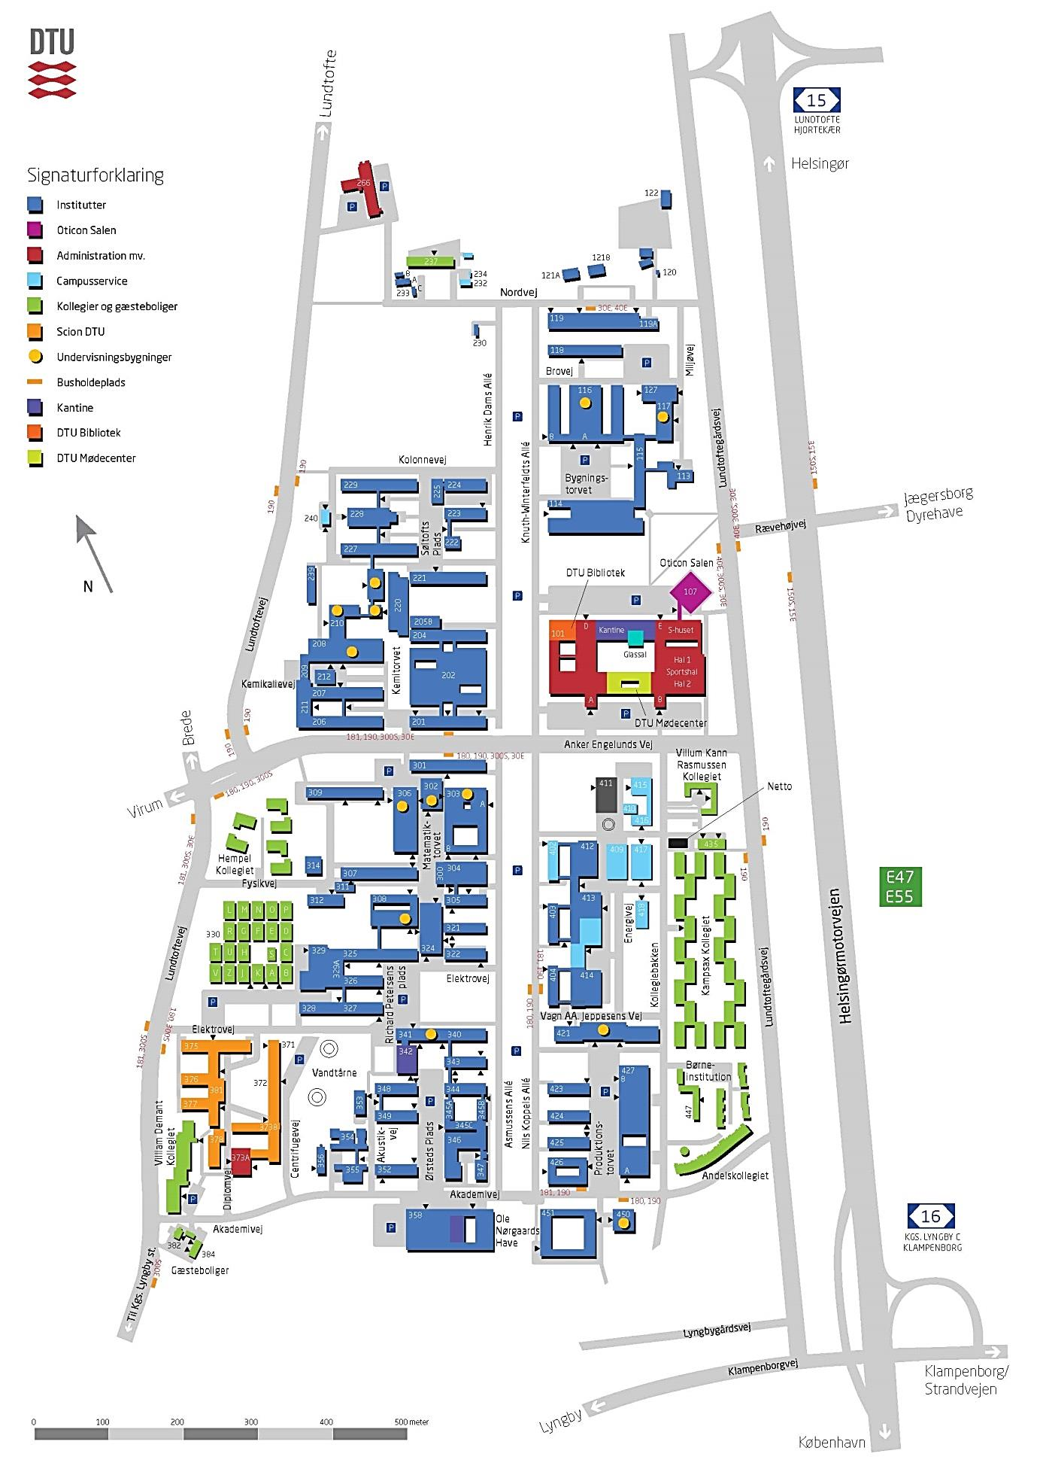

Annex 3 – Template for the evaluation report

Research evaluation of DTU XXX
Evaluation panel:
Title | Name | Place of employment
Prof. | Xx | Xx
Xxx | Xxxx | Xxxx
Xxx | Xxx | Xxx
Xxx | Xx | Xx
xxx | xxx | xxx

Date: dd/mm/yyyy

Preface
½-1 page preface

Sections

Section a
½-1 page about the section
Mark 1.0-4.0
Status here and now
Future recommendations

Section b

Section c

Section nn…

PhD school
½-1 page about the section
Mark 1.0-4.0
Status here and now
Future recommendation

Research facilities
½-1 page about the research infrastructures

Status here and now
Future recommendations

Executive summary: Department as such
½-1 page about the department as such
Mark 1.0-4.0
Status here and now
Future recommendations

Annexes

Annex 1: Panel members’ CV’s

In Danish “UMV - UdviklingsMål og Virkemidler” – in English “Development Goals and Measures”.
Such conflict of interest will be handled according to the guidelines laid down by The Danish Research Councils and by The Public Administration Act (§ 53)
DTU recognises that leadership skills are not depending on academic prominence.
Please contact the central coordinator if this is not possible (research-evaluation@dtu.dk)
Please contact the central coordinator if this is not possible (research-evaluation@dtu.dk)
Please contact the central coordinator if this is not possible (research-evaluation@dtu.dk)
engelsk-ph-d-bekendtgorelse.pdf (ufm.dk)
Industrial Researcher | Innovationsfonden
https://eua.eu/resources/publications/626:salzburg-2005-%E2%80%93-conclusions-and-recommendations.html
Appendix 5 concerning PhD Fellows in the Circular on collective agreement for academic staff working for the state (In Danish).
Please note that the Executive summary can be freely used by the department and shown to both DTU employees and externals.

