Guide – DTU background image in Teams
How to insert a new background image for online meetings in Teams.
You can download the DTU images from Inside, you will find them here

Open a Teams meeting.
Choose ’Background filters’.
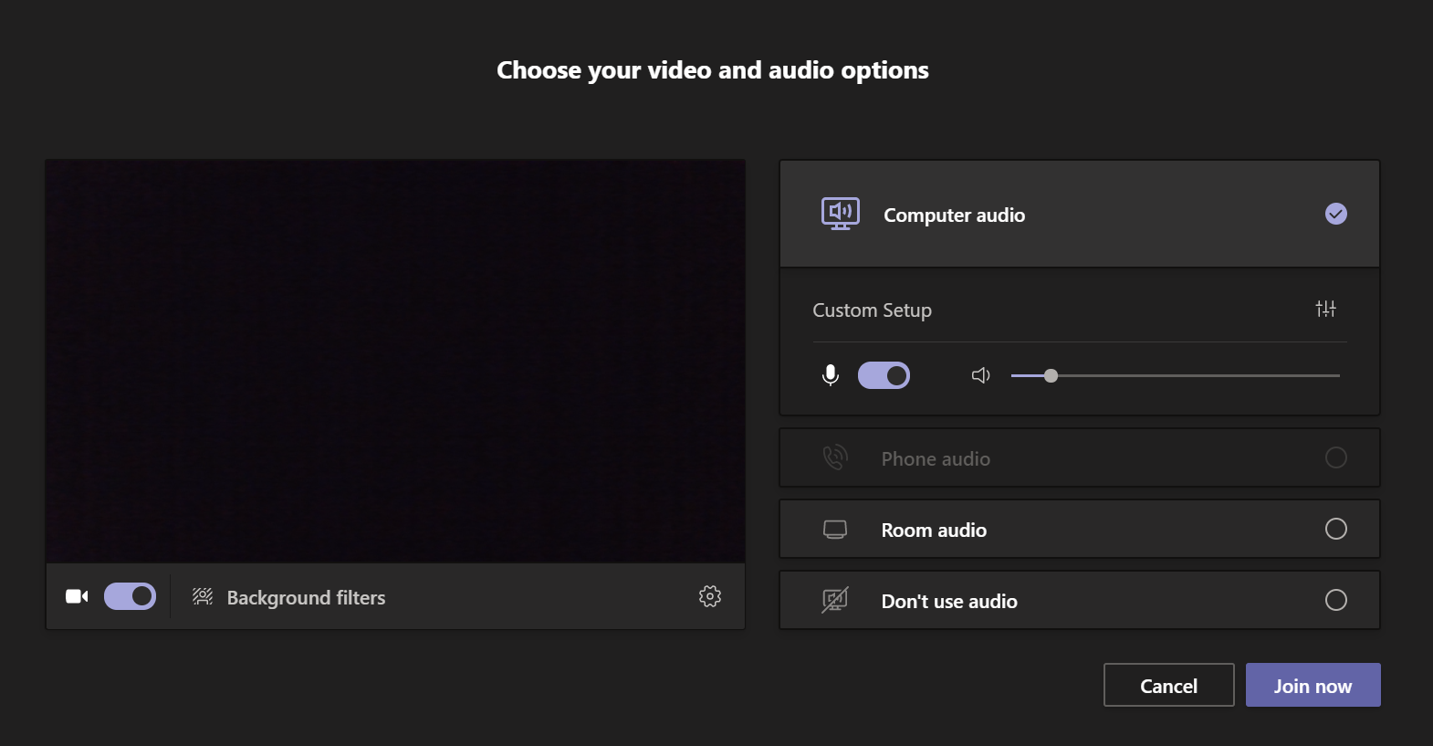

Click on ’Add new’.
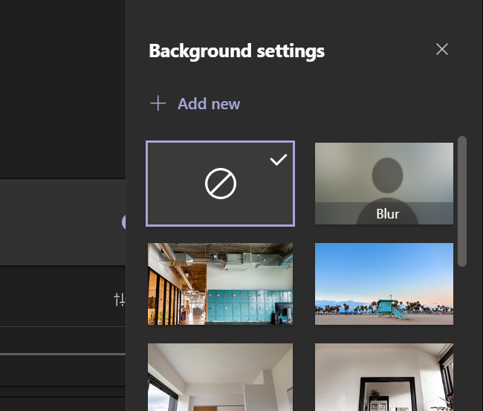

Browse to the destination in your PC where the images are saved.
Mark the image you want.
Click on Open. 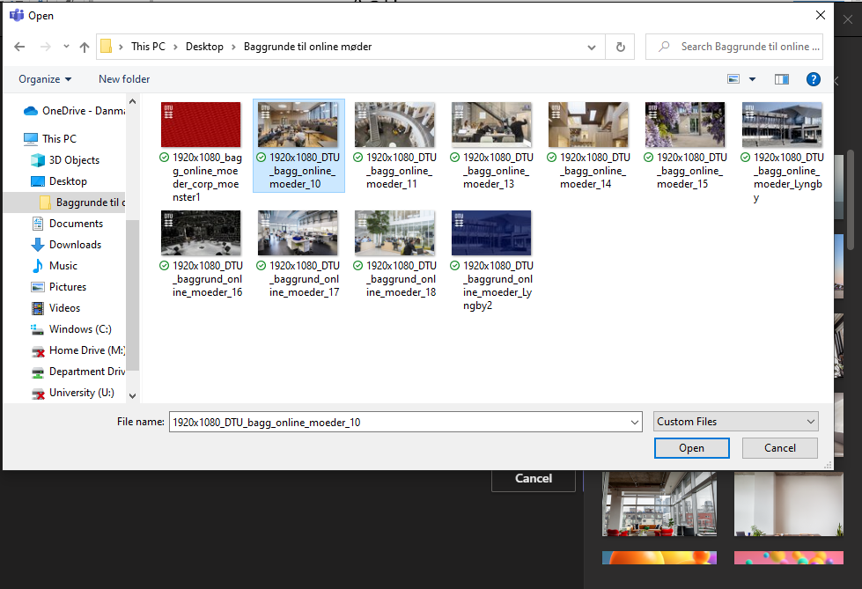

The added image is now be shown in the list of available background images.
Choose the image (the chosen image is marked with a light blue frame).
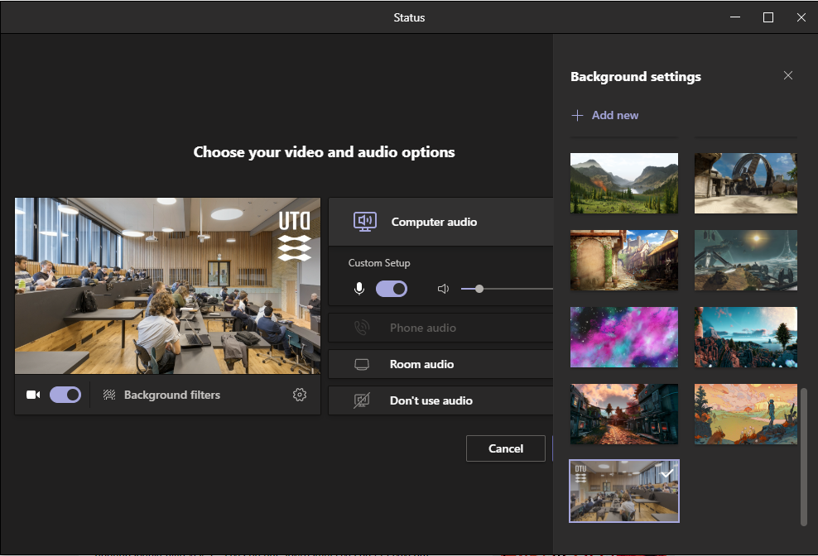
Close the panel ’Background settings’ by clicking the cross.
Next time you participate in a meeting, the chosen image is shown as background on your screen.
NB: The image (and the DTU logo) will present itself reversed, but is displayed correctly for the other participants.

